**TEAM 7**

DEVA SUDHA .M {LEAD}

SRAVANI .S

RENUKA RAMANI. B

JASWANTH . D

NAVVEN .P

**PROBLEM STATEMENT**

**STUDENT GRADES PREDICTION**

**Project Overview**

**Introduction**

This project aims to Predicting student grades is an intriguing and impactful field that combines data analysis, education, and technology. It involves using various techniques like machine learning, statistical models, and historical academic data to estimate how well students are likely to perform in their courses or exams. The goal isn't just to forecast grades but also to identify factors affecting academic success, such as study habits, participation, and socio-economic conditions.

**Objectives**

1. **Accurately forecast students' academic performance** using data-driven models and techniques.

2. **Identify key factors influencing student success** to support personalized interventions and improvements in education.

3. **Develop actionable insights** that help educators and institutions enhance learning outcomes effectively.

**Scope**

1. This project focuses on building a predictive model to estimate students' grades using academic and behavioral data.
2. It aims to support educators in identifying at-risk students and providing timely interventions.
3. The scope includes data collection, analysis, model development, and generating actionable insights to enhance educational outcomes.

**Background**

**Definition of CLV**

Customer Lifetime Value (CLV) is the total revenue a business can expect from a customer throughout their relationship. It is a critical metric for understanding customer profitability. **Importance of CLV Prediction**

Predicting CLV helps businesses:

* Allocate marketing resources effectively.
* Identify high-value customers.
* Enhance customer retention strategies.

**Data Requirements**

**Data Sources**

* Internal This project focuses on building a predictive model to estimate students' grades using academic and behavioral data.
* It aims to support educators in identifying at-risk students and providing timely interventions.
* The scope includes data collection, analysis, model development, and generating actionable insights to enhance educational outcomes.
* database.
* Students grades.

**Implementation**

**Tools and Technologies**

* Programming Language: Python
* Libraries: Pandas, NumPy, Scikit-learn, Matplotlib, Seaborn.
* Database: SQL for data extraction.
* 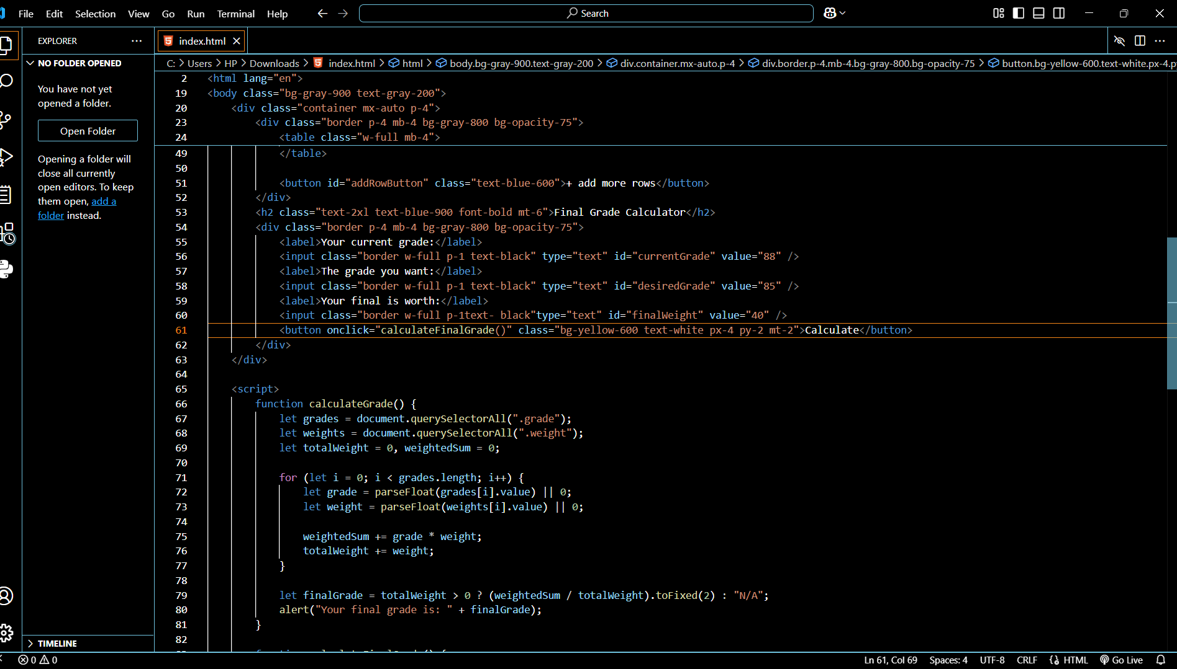

**Model Training and Evaluation**

Train the model using relevant academic data, fine-tuning parameters to ensure it effectively predicts student performance. Evaluate its accuracy with metrics like precision and recall, validating robustness through cross-validation techniques.

**Results**

**Model Performance Metrics**

* Summary of model performance (e.g., Accuracy , F1-Score, Mean Squared Error (MSE)0

**Visualization**

Visualize model performance metrics using bar charts, scatter plots, or heatmaps to effectively showcase accuracy, precision, and prediction trends.

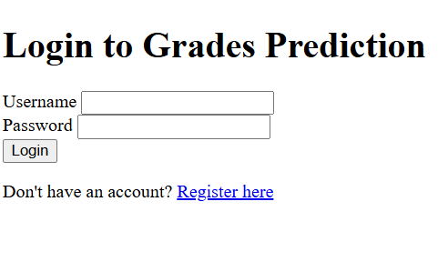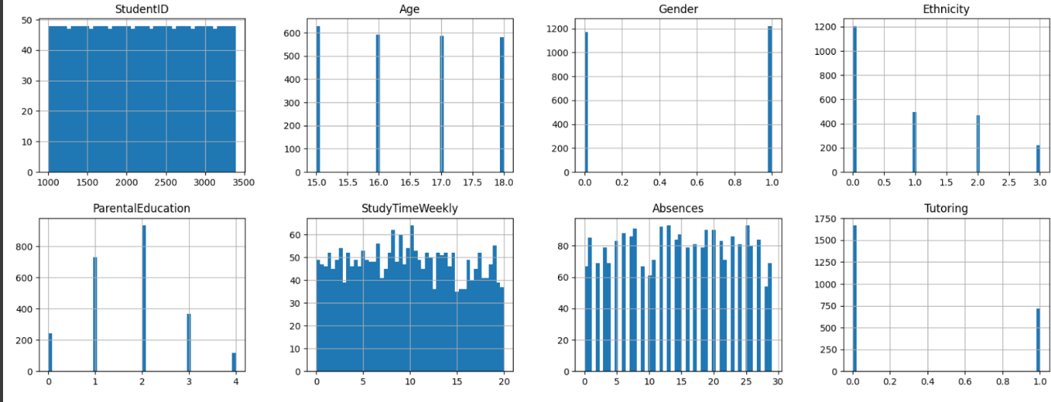

**Insights and Recommendations**

1. **Insights:** The model effectively predicts grades with high accuracy and identifies key factors like attendance and prior performance as strong predictors of success.

2. **Recommendations:** Encourage targeted academic support for at-risk students, based on model predictions, and implement strategies to address factors influencing performance, such as study habits or resource accessibility.

**Future Work**

Enhance Model Accuracy

Enhance Model Accuracy

Enhance Model Accuracy

**Conclusion**

This project successfully demonstrates the potential of predictive modeling in forecasting student grades. By leveraging academic and behavioral data, it provides valuable insights into factors affecting student performance and highlights opportunities for personalized interventions. With enhanced accuracy and broader applications in future work, this model has the capacity to transform educational outcomes and support targeted strategies for student success.